**BIGTAIC ONLINE SHOPPIG**

*Developer Guide*

|  |  |  |
| --- | --- | --- |
| **Supervisor.** | **Sir Shahryar** | |
| **Batch.** | **2207G2** | |
| **Group.** | A | |
| **Serial No.** | **Enrollment Number** | **Student Name** |
| 1. | Student1388784 | ZARYAB AHMED KHAN NIAZI, |
| 2. | Student1397261 | SYED QAISER ALAM, |
| 3. | Student1397281 | WAJEEH ABDUL REHMAN, |
| 4. | Student1395050 | NASAR KHAN |

1. **Home** (*index.html*)

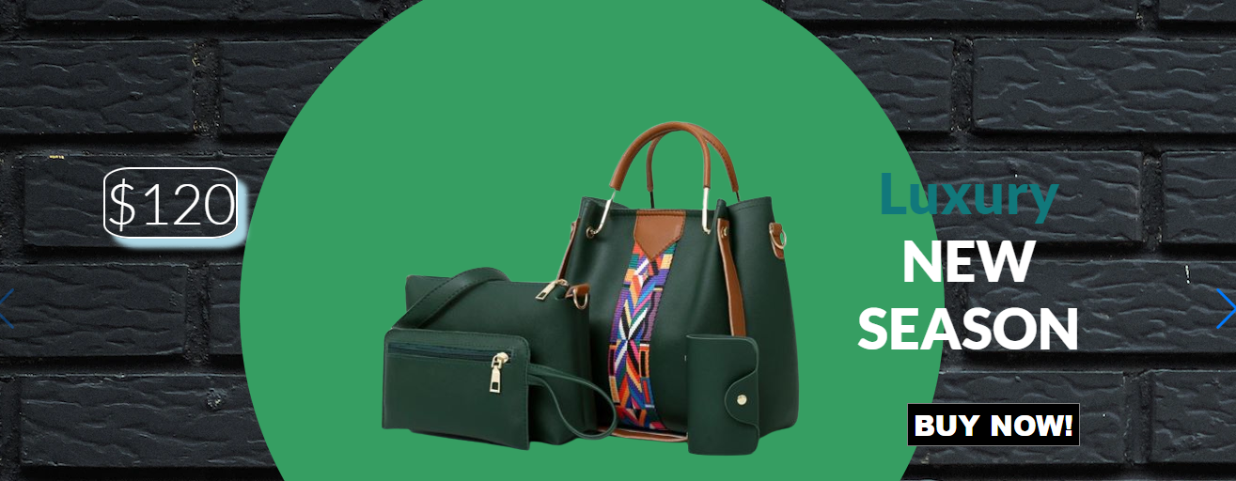

***Figure 1: Home page to Nexus aquarium***

Arrow Slight curve  Our Slogan has given to the peoples toward our website. “**BAGTASTIC ONLINE SHOPPING**”.

* By clicking (**Aero**) button user while redirect to the next image.

**Code of Home page**

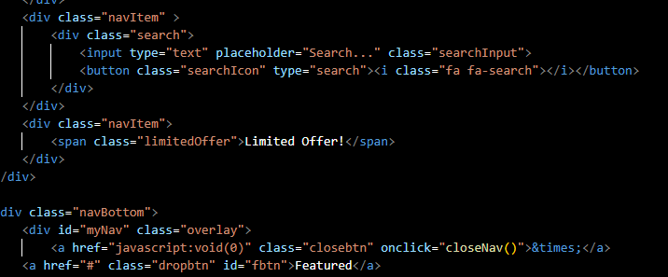

1. **Navbar (index.html)**

**

***Figure 2: Navbar***

We have given five essentials. By clicking any of the essential’s and redirect to the linked page.

**Code of Navbar**

<nav class="navbar navbar-expand-lg fixed-top ">

    <div class="container-fluid">

      <a class="navbar-brand" href="#" data-aos="slide-right" data-aos-delay="1000"><img src="images/my logo.png" alt=""

          class="logo"></a>

      <button class="navbar-toggler" type="button" data-bs-toggle="collapse" data-bs-target="#navbarNavDropdown"

        aria-controls="navbarNavDropdown" aria-expanded="false" aria-label="Toggle navigation">

        <span class="navbar-toggler-icon"></span>

      </button>

      <div class="collapse navbar-collapse justify-content-center" data-aos="slide-up" data-aos-delay="1000"

        id="navbarNavDropdown">

        <ul class="navbar-nav">

          <li class="nav-item">

            <a class="nav-link nav-hover" aria-current="page" href="index.html">Home</a>

          </li>

          <li class="nav-item">

            <a class="nav-link nav-hover" href="about.html">About us</a>

          </li>

          <li class="nav-item">

            <a class="nav-link nav-hover" href="contactus.html">Contact</a>

          </li>

**3.About us**

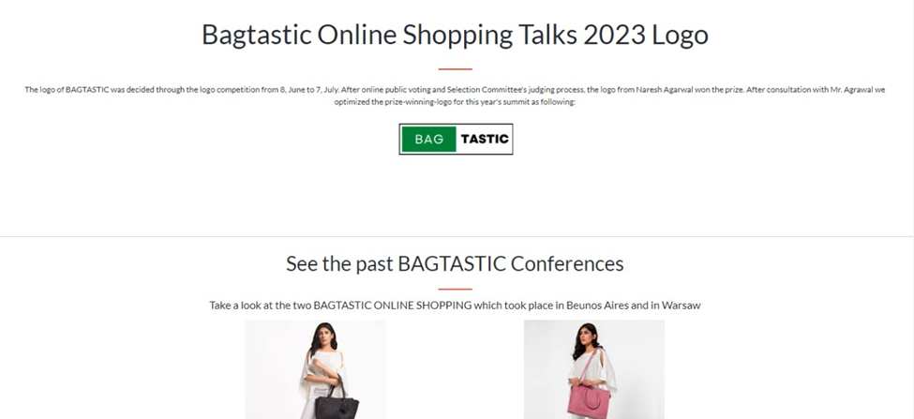



 ***Figure 3: About us***

**

*Arrow Slight curve In our abouT us section we have given our services to people known about the service we provide.*

***Arrow Slight curve*** *we are giving fastest services to the costumer*

* *.we have a wide range of online payment*

***Code of About Us***

<div class="container about-top justify-content-center d-flex">

      <div class="waviy" data-aos="fade-down">

        <span style="--i:1">A</span>

        <span style="--i:2">B</span>

        <span style="--i:3">O</span>

        <span style="--i:4">U</span>

        <span style="--i:5">T</span>

        <span style="--i:6"></span>

        <span style="--i:7">U</span>

        <span style="--i:8">S</span>

       </div>

    </div>

    <section class="about-sec" data-aos="fade-up">

      <div class="container py-5">

        <div class="row">

          <div class="col col-12 col-sm-6 col-md-6 col-lg-3 ">

          <div class="about-card" id="item-card" data-aos="fade-right">

          <img src="images/bag.png" alt="" class="about-icon">

          <div class="about-card-text">

          <h4 class="text-center">More than 100 + items Available</h4>

        </div>

1. **Contact us :**

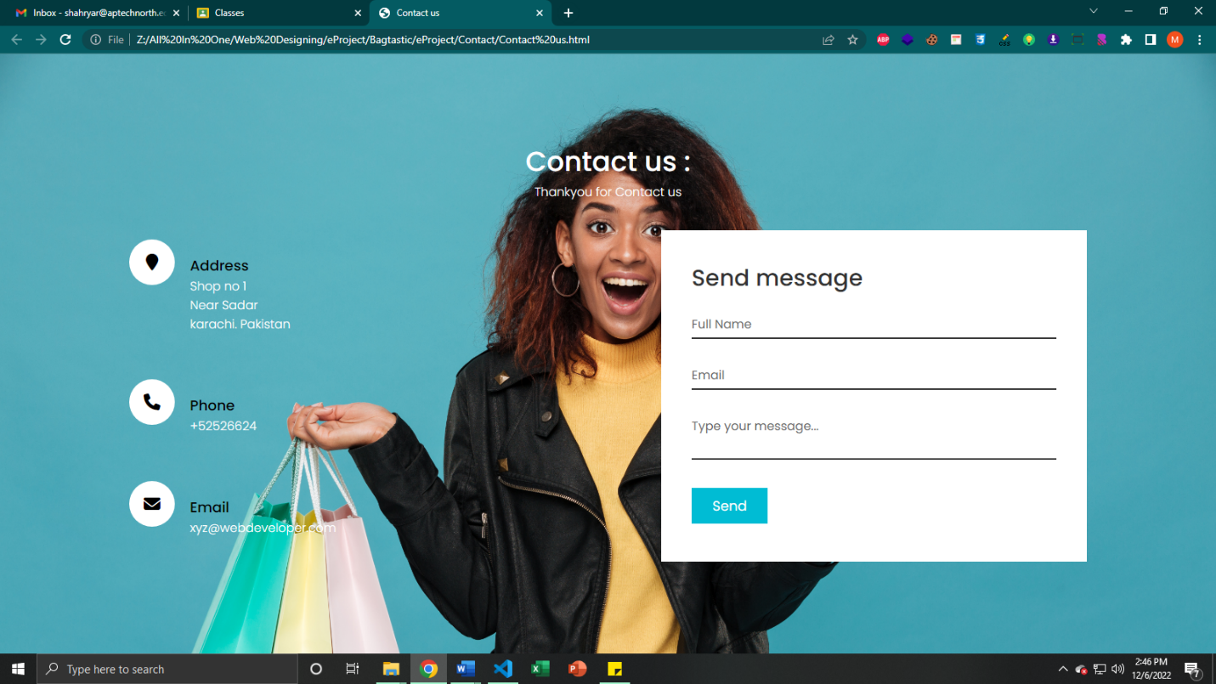

***Figure 4: Contact***

*In our contact section we have given location map for the ease of the people*

*Email id and phone number for contacting in case of any problem.*

*Feedback Form:*

*To know the response of the people our team has given feedback page for the ideas and feedback of the people.*

***Code of Contact***

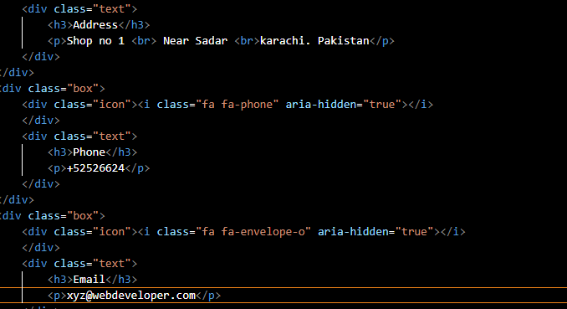

***4.Comparision page:***

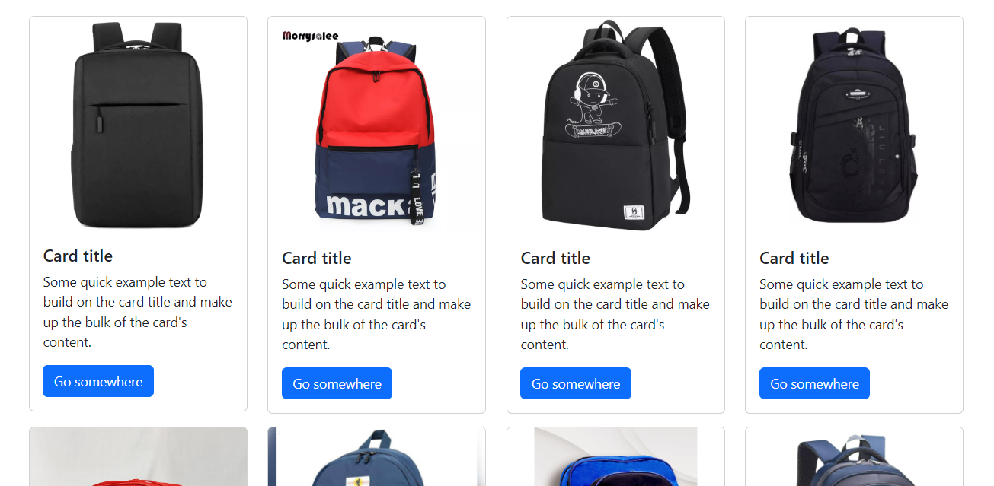

***Figure: 6 comparision page***

*Our comparision site does not typically do anything that you can’t do yourself -but it takes a fraction of the time .Even if you could thing of all the different providers to try , filling in each individuals quote request would take you many hours.*

***Code of comparision page:***

 <section class="cd-products-comparison-table margin-sec">

    <div class="cd-products-table">

      <div class="features">

        <div class="top-info">Our Products</div>

        <ul class="cd-features-list">

          <li>Brand</li>

          <li>Material</li>

          <li>Pattern</li>

          <li>Quantity per pack</li>

          <li>price</li>

          <li>ratings</li>

        </ul>

      </div>

      <!-- .features -->

      <div class="cd-products-wrapper">

        <ul class="cd-products-columns">

          <li class="product">

            <div class="top-info">

              <div class="check"></div>

              <img src="images/tableware-dinner-set-500x500.jpg" alt="product image">

            </div>

***5.Categories:***

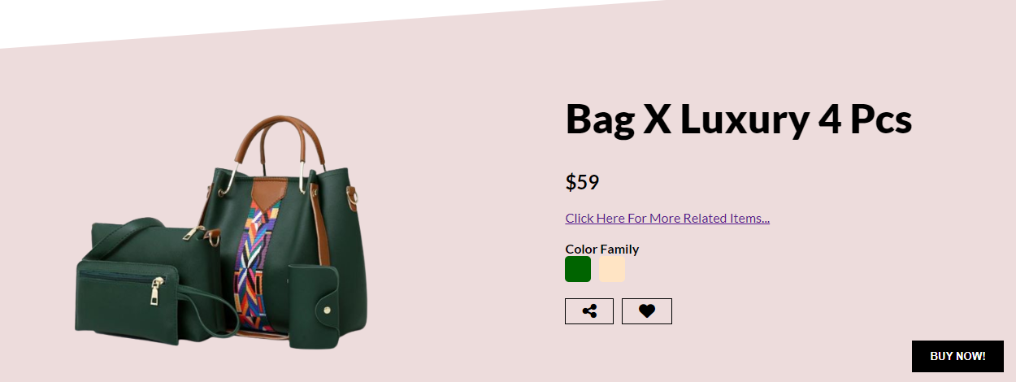

***Figure:7 comparision page***

*we provide different categories pages like kitchen tools, Baking tools, ceramics, BBQ’S.*

***Code of comparision page:***

   <div class="swiper-slide">

            <div class="sliderItem menuItem">

                <img src="./stock/gbag2 (1).png" alt="" class="sliderImg">

                <div class="sliderBg"></div>

                <h1 class="sliderTitle"><span class="Sale">Stylish</span></br> NEW</br> SEASON</h1>

                <h2 class="sliderPrice">$30</h2>

                <a href="#product">

                    <button class="buyButton">BUY NOW!</button>

                </a>

            </div>

          </div>

          <div class="swiper-slide">

            <div class="sliderItem menuItem">

                <img src="./stock

                " alt="" class="sliderImg">

                <div class="sliderBg"></div>

                <h1 class="sliderTitle"><span class="Sale">Backpack</span></br> NEW</br> SEASON</h1>

                <h2 class="sliderPrice">$99</h2>

                <a href="#product">

                    <button class="buyButton">BUY NOW!</button>

                </a>

            </div>

          </div>

***6. footer:***

***Figure 14: Footer***

We have given some copyrights are given in the end of the website and effects of Facebook Instagram and twitter are also mentioned for making the website attractive



***CODE OF FOOTER:***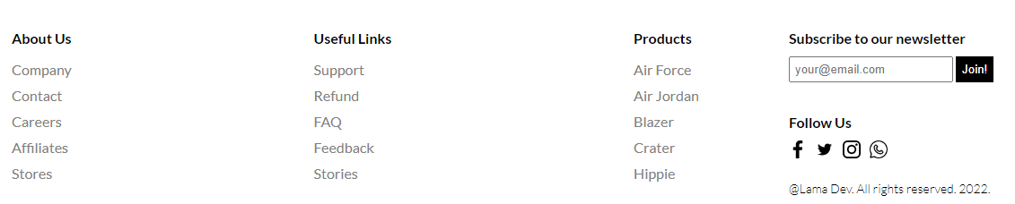 <footer class="footer-section">





